Introduction
Background:
Solar OS is a Linux-like operating system designed for speed, efficiency, and security. Virtual environments allow testing of OS without affecting the host machine.
Motivation:
Learning to install Solar OS in a virtual machine provides hands-on experience, enables safe testing, and helps understand filesystem management and virtualization.

2. Objectives
1.Install Solar OS in a virtual environment.
2.Understand filesystem support.
3.Document installation with screenshots.
4.Solve common issues during installation.
5.Explain virtualization concepts.

3. Requirements

a. Hardware
Component | Requirement
CPU | Intel/AMD, 2+ cores, VT-x / AMD-V supported
RAM | Minimum 4GB, recommended 8GB
Storage | 20GB free disk space
Graphics | Any standard GPU
Internet | Stable for updates

b. Software
Software | Version / Notes
Virtualization Tool | VMware Workstation / VirtualBox latest version
Solar OS ISO | Latest stable release
Guest Additions / VMware Tools | Optional but recommended

1.Installation of oracle VM VirtualBox
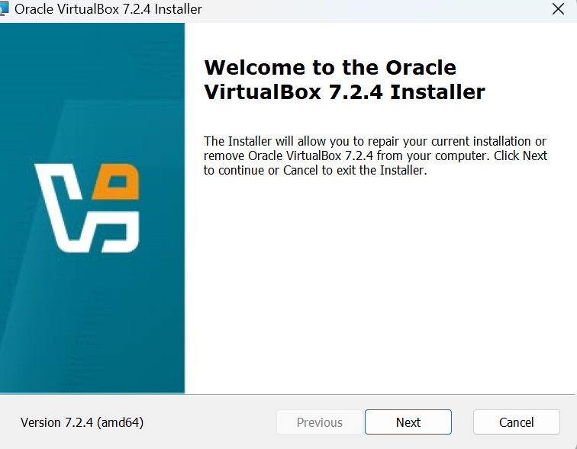

Figure 1.1:Welcome screen of Oracle VM VirtualBox Installer

Purpose:
●Shows the initial step of creating a virtual machine in VirtualBox/VMware.
●Highlights selected ISO, VM name (your full name), RAM allocation, and CPU cores.
What to Include:
A.Window where ISO is selected.
B.RAM and CPU allocation visible.
C.VM name clearly showing your full name.
Why Important:
Demonstrates your ability to configure a VM properly, a key requirement in the evaluation criteria.

Virtual Disk Configuration Screenshot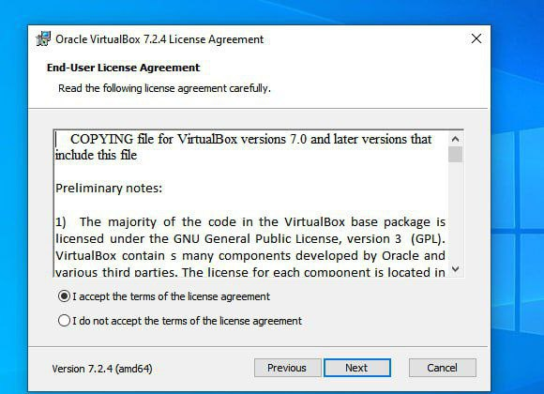
Figure 1.2: Igreement To Installation
Purpose:
●Shows disk type (VDI / VMDK), size, and dynamically allocated vs fixed size.
●Visual proof of storage allocation and correct settings for VM use.
What to Include:
√ Disk creation window with type and size clearly shown.
√ Dynamic allocation option highlighted.
Why Important:
√ Disk setup affects performance, storage efficiency, and system stability.

Network & USB Settings Screenshot
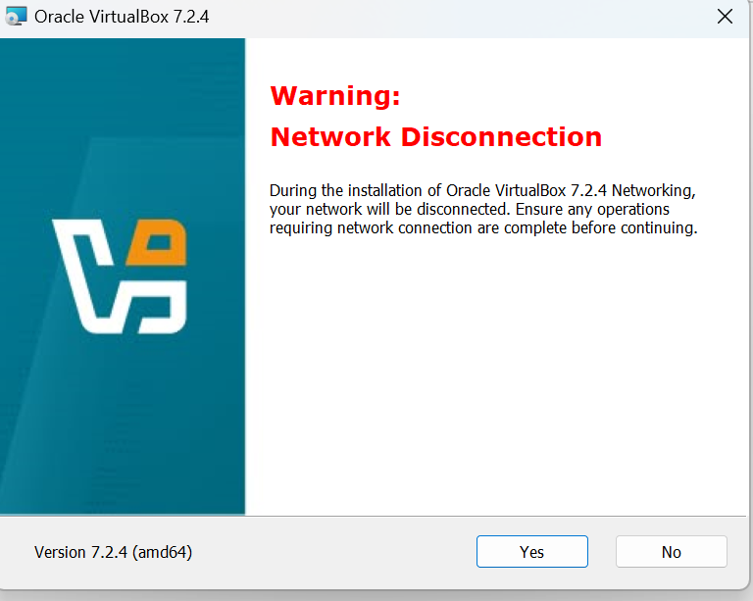
Purpose:
● Shows network adapter configuration (NAT or Bridged).
● USB support enabled (2.0/3.0).
What to Include:
√ Network type selected
√ USB controller enabled
Why Important:
√ Ensures internet access, host-device integration, and proper connectivity for OS updates.

Solar OS Boot Menu Screenshot

Purpose:
●Shows booting from ISO, selection of Install Solar OS option.
What to Include:
√ Boot menu with ISO name
√ Install option highlighted
Why Important:
√ Proof of successful boot of the VM from ISO, a critical step before installation.

User Account Creation Screenshot
●I don’t have create Account because oracle website do not allowed to me for installing correct iso image

Purpose:
● Shows creation of a user account with your full name.
√ Captures password setup, username, and timezone selection.
What to Include:
√ User creation window
√ Your full name in username field
Why Important:
Demonstrates personalized OS setup and attention to the instructions.

Post-Installation Desktop Screenshot
●I have n’t post-instalation Desk Top
Purpose:
√ Shows successful completion of installation.
√ Displays the Solar OS desktop environment after first boot.
What to Include:
√ Desktop environment with taskbar or icons
√ Any system notifications confirming updates
Why Important:
Proof that the OS is fully installed and running properly.

Filesystem Selection Screenshot
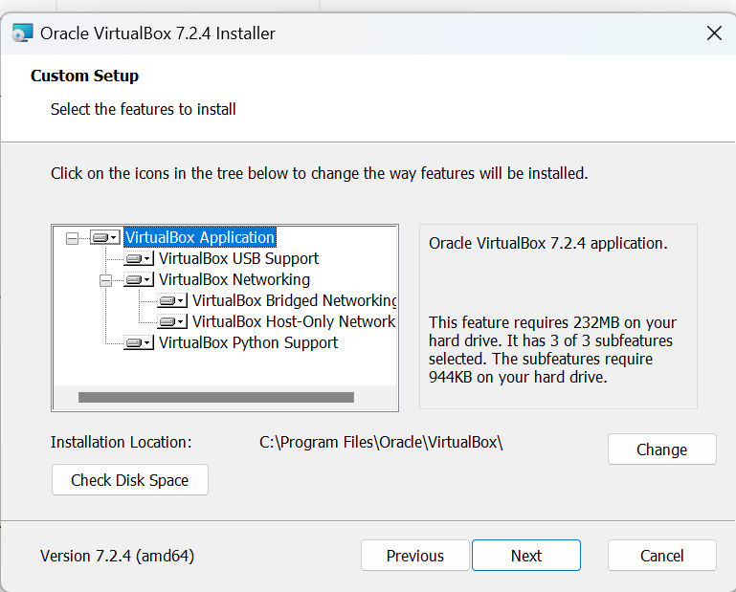
Purpose:
√ Demonstrates filesystem chosen during installation (e.g., ext4).
What to Include:
√ Partitioning window
√ Highlight selected filesystem
Why Important:
√ Shows technical knowledge of why ext4 is chosen over others (NTFS, FAT32, Btrfs, etc.) — relevant to evaluation criteria on filesystem understanding.

Installation Issues Screens 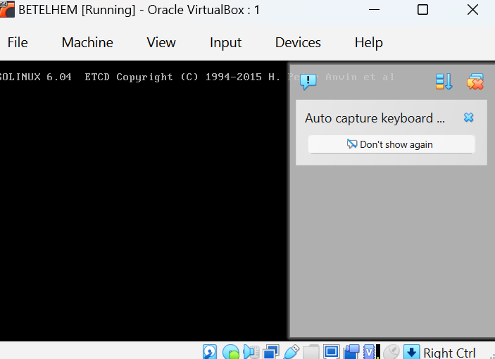

Purpose:
√ Shows any errors or problems faced during installation (e.g., boot failure, network issue, low resolution).
What to Include:
√ Error message visible
√ Any pop-up or console warning
Why Important:
Evaluates your problem-solving skills. Screenshots make your documentation transparent and credible.

Solution Screenshot(s)
●I can not a solution
Purpose:
√ Shows fix applied to solve issues (e.g., Guest Additions installed for screen resolution, correct network adapter selected).
What to Include:
√Settings window or terminal output confirming solution
Example: Network connected after adapter change, resolution improved
Why Important:
√ Demonstrates understanding of OS and virtualization troubleshooting.

Final Desktop Screenshot
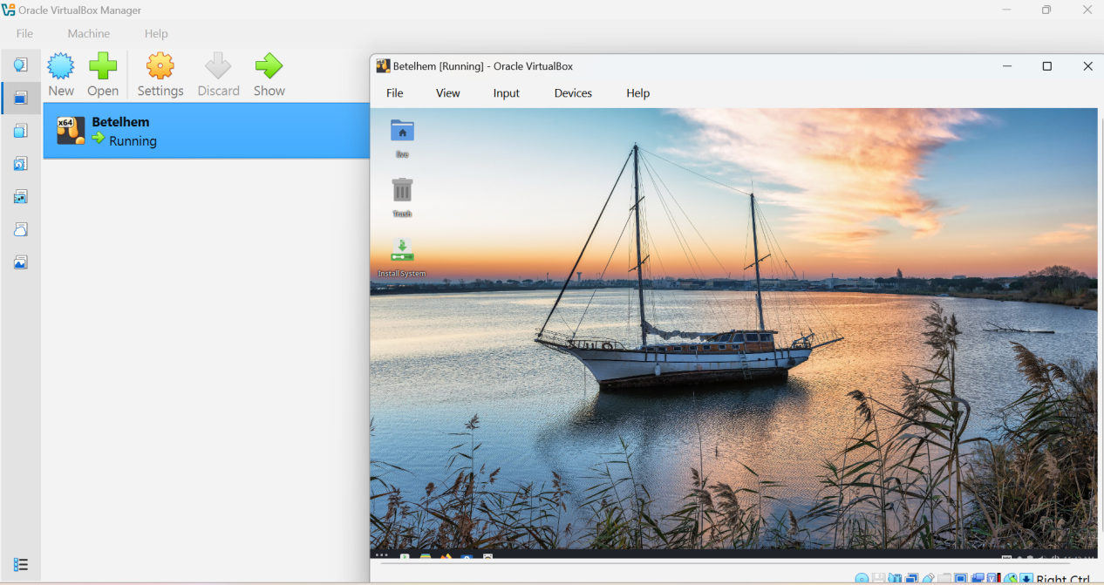
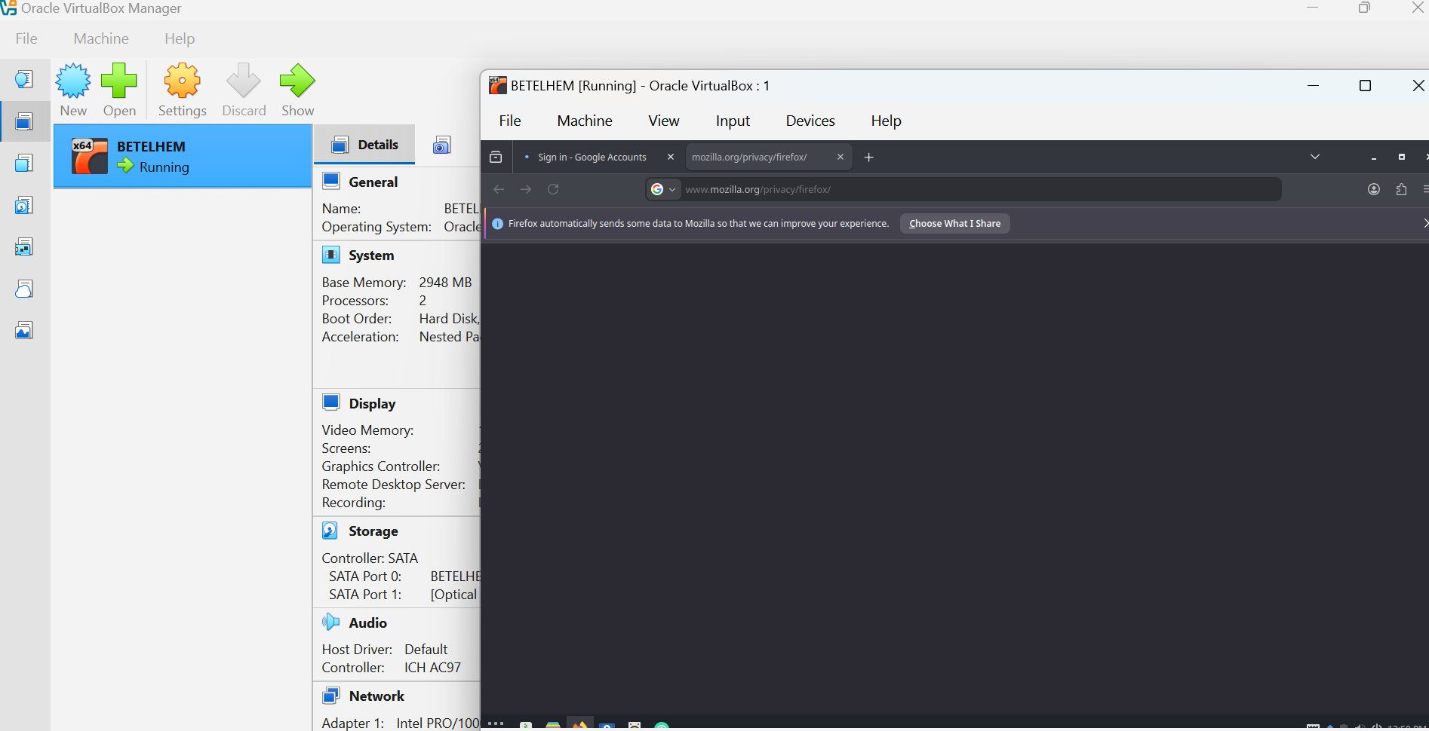

Figure Last Screenshot

Issues Faced (Problems)
Figure 5.1:Network connection Error

Solutions
● Solution for Fig5.1:-I go to network connection and connect my computer to network .and finally continue installation.
7.Solar Operating Sytem Support Filesystem
√ NTFS
√ FAT32
√ exFAT
√ ext4
√ Btrfs
√ ZFS
√ HFS+
√ APFS
Recommended for Solar OS: ext4
Stable, widely supported, journaling enabled, efficient for VM use.
Insert Screenshot Here (Filesystem Selection):
[Paste screenshot of filesystem selection here]

Advantages & Disadvantages

Advantages Disadvantages
√ Safe testing environment √ Slightly slower than bare-metal installation
√ Snapshots / restore √Limited hardware acceleration
√ Learn OS and filesystem features √ Requires sufficient host resources
√ Isolated from host √ USB/GPU pass-through complex

9. Conclusion
Installing Solar OS in a VM provides practical experience in OS installation, configuration, and virtualization. Using ext4 filesystem ensures stability and efficiency. Virtualization allows safe testing without affecting the host system.
Insert Screenshot Here (Final Desktop):
[Paste screenshot of fully installed Solar OS desktop here]

10. Future Outlook / Recommendations
√ Explore multiple virtualized OS setups.
√ Test advanced filesystems like Btrfs or ZFS.
√ Use VM snapshots for safe experimentation.
√ Benchmark VM performance vs bare-metal.

11. Virtualization Concepts
What: Running multiple OS instances on a single physical computer using virtual hardware.
Why: Efficient resource utilization, safe testing, isolation, snapshot/restore capability.
How:
√ Hypervisors abstract physical hardware.
Type 1: Bare-metal (directly on hardware)
Type 2: Hosted (runs on host OS, e.g., VirtualBox, VMware Workstation)
Allocate CPU, RAM, disk, and network to the VM.

